**Object Detection and Recognition(Covid19)**5TH Semester Project

**B.Tech**

**In**

**Computer Science Technology**



**Submitted By:**

**Anurag Bhatt**

Roll No. : 2015293

C.S.T.(5th sem)

        Batch: 2019-2023

**Department of Computer Science and Information Technology**

**Graphic Era Deemed to be University**

**Dehradun, Uttarakhand**

**DECLARATION**

I, **Anurag Bhatt** students of **B.Tech CST 5th Sem**, Department of Computer Science and Technology, Graphic Era Deemed to be University, Dehradun, declare that the technical project work entitled **Object Detection and Recognition** has been carried out by me and submitted in partial fulfilment of the course requirements for the award of degree in **Bachelor of Computer Science & Technology** of **Graphic Era Deemed to be University, Dehradun** during the academic year **2020-2021**. The matter embodied in this synopsis has not been submitted to any other university or institution for the award of any other degree or diploma.

**Place: Dehradun**

**Date: 16-12-2021**

**CERTIFICATE**

This is to certify that the project report entitled **Object Detection and Recognition** is a bonafede project work carried out by **Anurag Bhatt University Roll no 2015293** in partial fulfilment of award of degree of **Bachelor of Computer Science & Technology** of Graphic Era Deemed to be University, Dehradun, during the academic year 2020-2021.  It is certified that all corrections/suggestions indicated for internal assessment have been incorporated. The project has been approved as it satisfies the academic requirements associated with the degree mentioned.

**Dr. Manoj Diwakar**

**Project Guide**

Dept. of Computer Science

       GEU, Dehradun.

**ACKNOWLEDGEMENT**

Here by we are submitting the project report on **Object Detection and Recognition**, as per the scheme of Graphic Era Deemed to be University, Dehradun.

In this connection, we would like to express our deep sense of gratitude to our beloved institution Graphic Era Deemed to be University and also we would like to express our sincere gratitude to **Dr. Devesh Pratap Singh,** Head of Dept. of Computer Science, for providing a congenial environment to work in and carry out our project.

We consider it our cardinal duty to express the deepest sense of gratitude to **Dr. Manoj Diwakar** our mentor of **Object Detection and Recognition** for the invaluable guidance extended at every stage and in every possible way.

Finally we are very much thankful to all the faculty members of the Department of Computer Science, friends and our parents for their constant encouragement, support and help throughout the period of project conduction.

**Name-Anurag Bhatt**

                         University Roll no-2015293

**Introduction**

Deep neural networks have gained fame for their capability to process visual information. Among the key problems neural networks can solve is detecting and localizing objects in images.

## Object Detection and Recognition

Object Detection is a mixture of Object Classification and Localization.It is the identification of a bounding box outlining the object we wish to detect. Object recognition helps us to identify the object(What the object is?) and when combined with object detection, it tells us where the object is located on the screen.

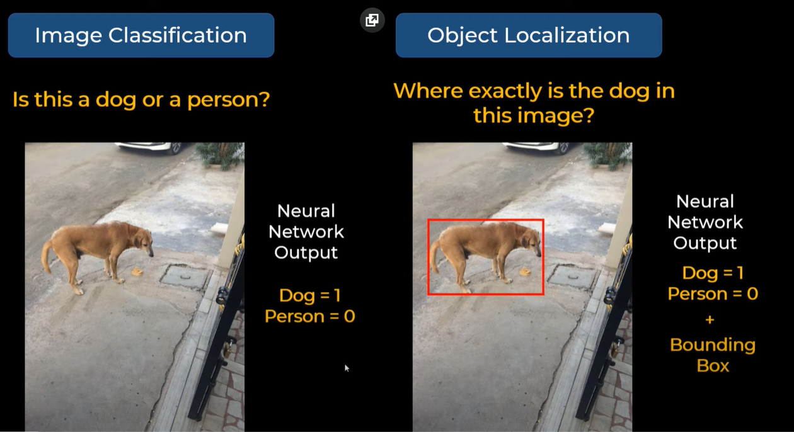

Object detection is used in many different domains, including [autonomous driving](https://bdtechtalks.com/2018/09/17/self-driving-cars-ai-computer-vision/), video surveillance, and healthcare.

In this project I have used Object Detection and Recognition **to detect whether a person’s face is covered with mask or not.**

**Motivation**

The COVID-19 pandemic, also known as the coronavirus pandemic, is an ongoing global pandemic of coronavirus disease 2019 (COVID-19) caused by severe acute respiratory syndrome coronavirus 2 (SARS-CoV-2). The World Health Organization (WHO) declared a Public Health Emergency of International Concern on 30 January 2020, and a pandemic on 11 March 2020. Multiple variants of the virus emerged, led by the Alpha, Beta, Gamma, Delta and Omicron variants.

And now the B.1.1.529 variant was first reported to WHO from South Africa on 24 November 2021 also know as Omnicron. This variant has a large number of mutations, some of which are concerning. In recent weeks, infections have increased steeply, coinciding with the detection of B.1.1.529 variant. As of 15 December 2021, more than 271 million cases and 5.32 million deaths have been confirmed, making the pandemic one of the deadliest in history. This rapid spread must be controlled by taking suitable precautions and wearing mask is one of the effective social measure in terms of normalizing the curve. Therefore, considering all these factors, this research project proposes an AI based detection system that helps in detecting any kinds of violations. This research intends on building a model that can be applied in real-time systems and thus help in avoiding the spread of the virus.

**Methodology** **Followed**

In this project I have used **YOLO(You only Look Once)** algorithm to detect and recognise whether a person’s face is covered with mask or not.

# YOLO

YOLO is almost standard way of detecting object in field of Computer Vision.It uses convolutional neural networks (CNN) to detect objects in real-time. As the name suggests, the algorithm requires only a single forward propagation through a neural network to detect objects.

## CNN(Convolutional neural network)

CNN’s are very powerful tools for identifying objects within images. It is inspired by how our brain identifies objects using signals received from our retina.

CNN is a particular type of feed-forward neural network in AI. It is widely used for image recognition. CNN represents the input data in the form of multidimensional arrays. It works well for a large number of labeled data. CNN extract the each and every portion of input image, which is known as receptive field. It assigns weights for each neuron based on the significant role of the receptive field. So that it can discriminate the importance of neurons from one another. Each individual neuron work on specific sub task and passes result to the next group.

The architecture of CNN consists of three types of layer: (1) convolution, (2) pooling, and (3) fully connected.

# How YOLO works?

The CNN is used to predict various class probabilities and bounding boxes simultaneously.In term of neural network output consider a vector like this ->

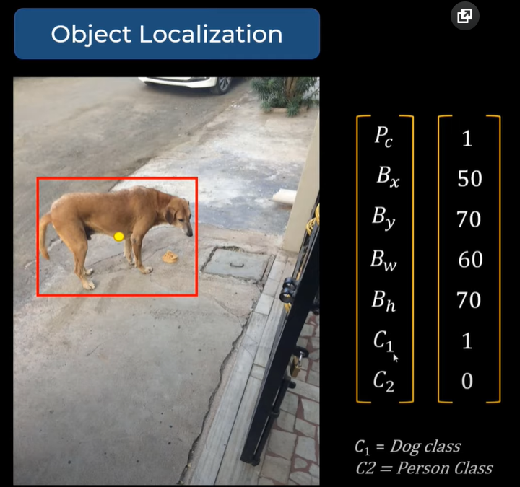

In object localization we are not only telling which class it is but we are also showing the bounding box(i.e. position of the object within the image).

Here image after processing through a CNN generates an Vector-

Pc - probability of the class

Bx & By – coordinates of centre of the bounding box

Bw & Bh - Width and height of bounding box

C1 & C2 – are two different classes

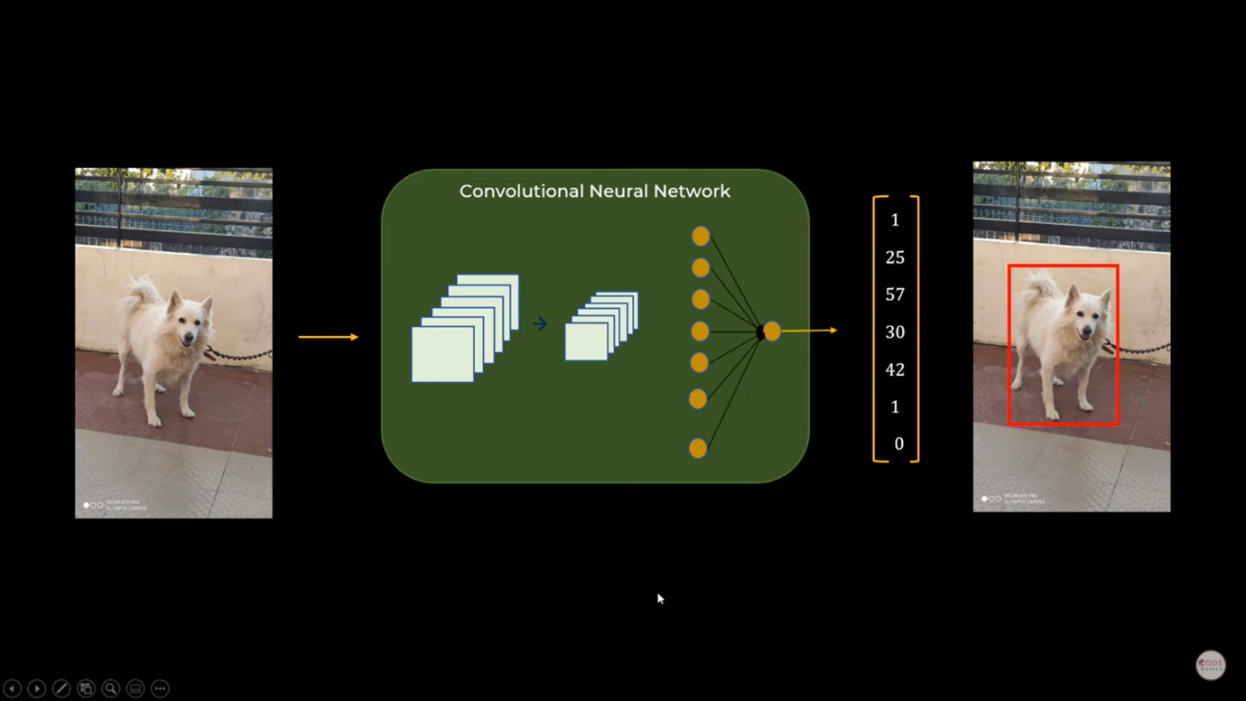

Train the neural network in a way that it produces this vector output.

This only work for single object.

# For Multiple Objects-

In this case YOLO Algorithm will divide the image into grid form (here 4 by 4 by 7) & for each grid there will be a vector generated (16 per vector in training image).

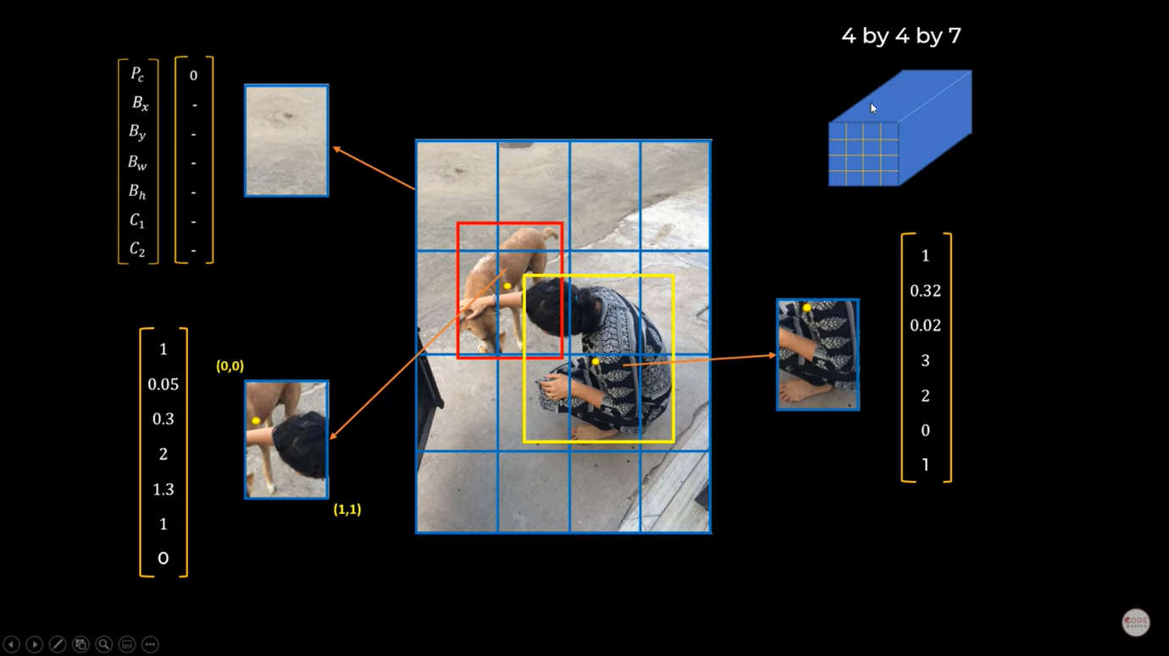

After training the data set it is capable of prediction in one pass.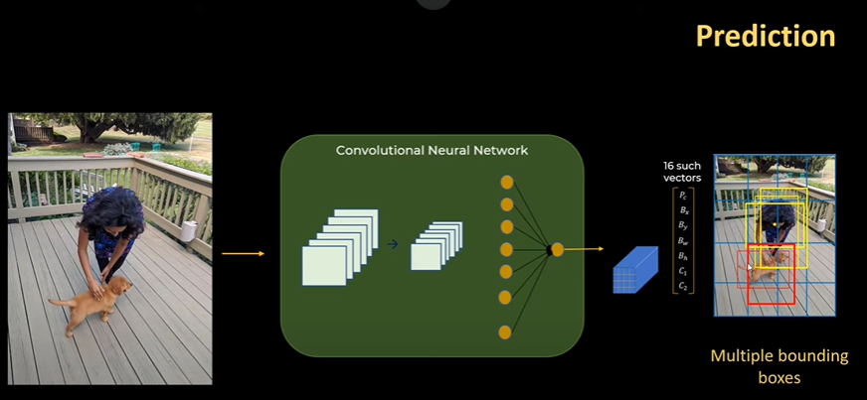

# But how to tackle multiple Bounding Box?

# We use IOU(Intersection Over Union)

IOU = intersect area/union area

correct if IOU>=0.5

higher the IOU more accurate the prediction is.

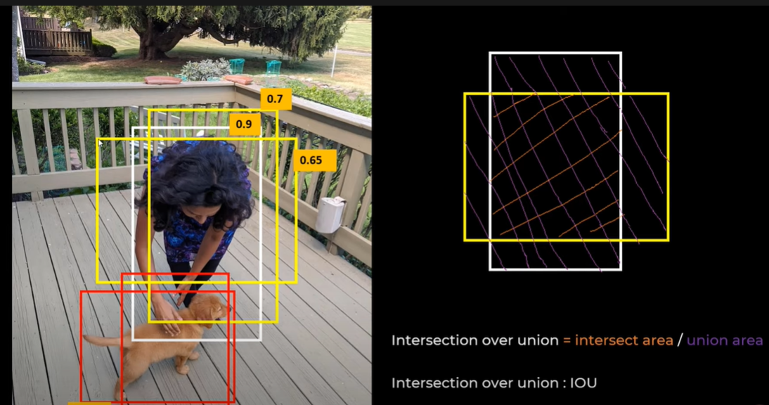

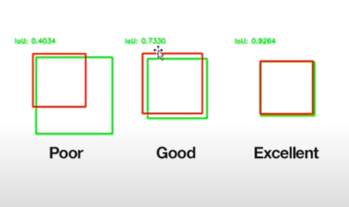

# NON MAX Suppression

It is a common algorithm used for cleaning up when multiple boxes are predicted for the same object.

It will clean up our results:

1.Discard all boxes with IOU probability less or equal to 0.6.  
2.Pick the box with the largest probability output as a prediction.  
3.Discard any remaining box with IOU greater than or equal to 0.5.

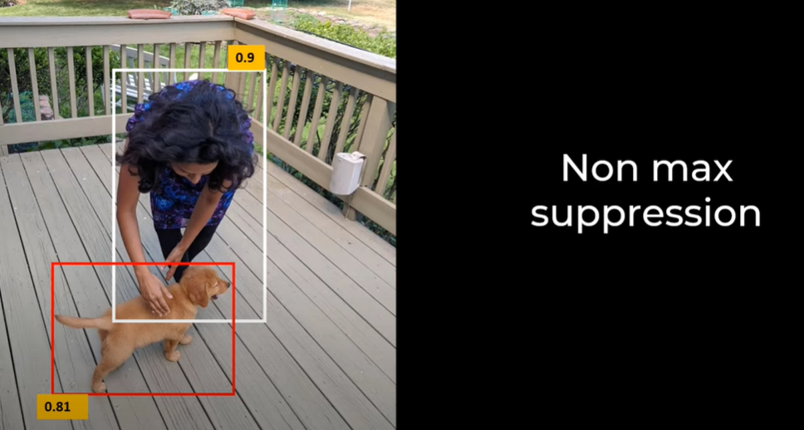

# Anchor Box

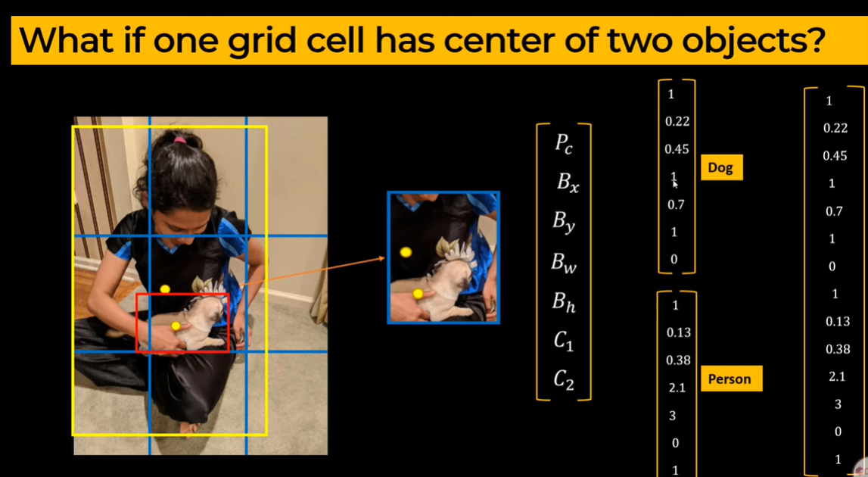

Instead of seven size vector we will concat the two classes into 14 size vector. This concept is called anchor boxes.

Implementation

## PLatform used

Google Colab

# Dataset and Framework Used

Labelled Custom Dataset with more than 1000 images is used along with separate train and test files of two classed – **with mask and without mask**

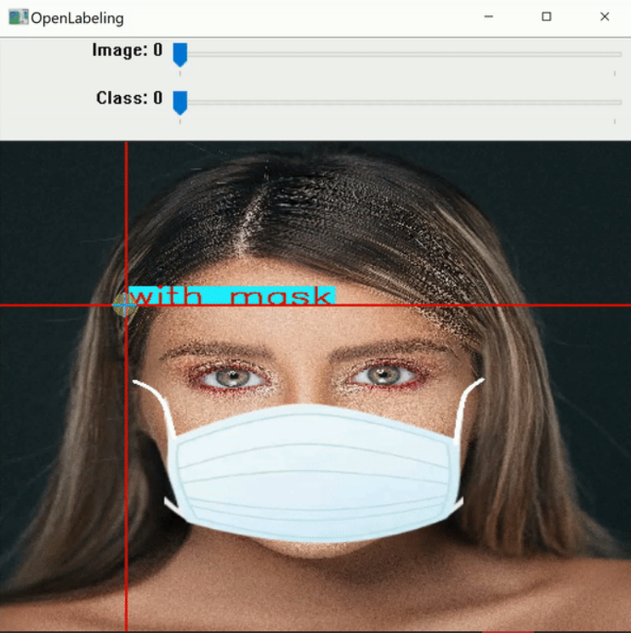

AlexeyAB Darknet framework along with custom config file

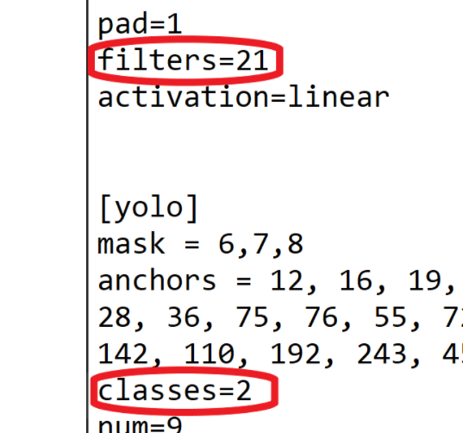  
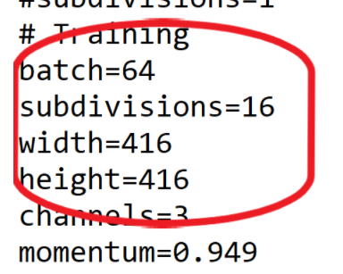

batch=64 subdivision=16 and filters=27 along with 2 class is used

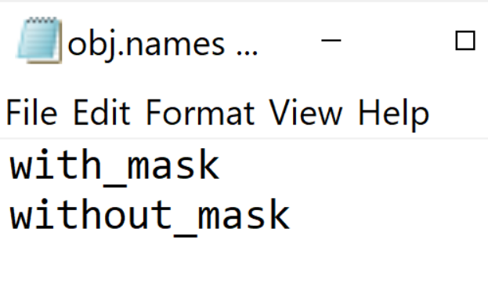 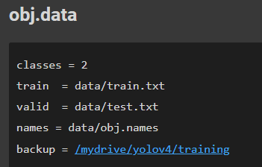

## Training our Custom Dataset



Training our dataset for almost 1000 iterations.

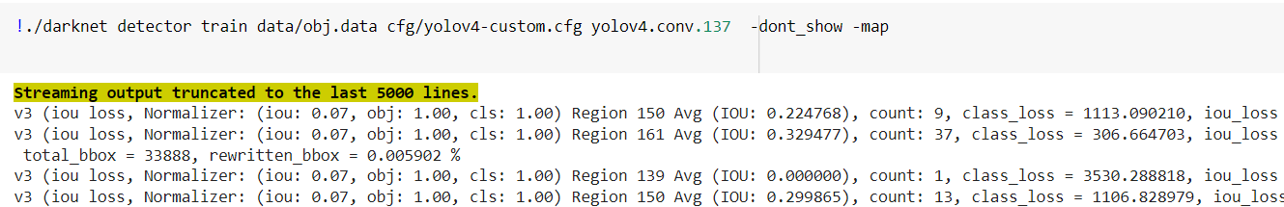

## Analysis

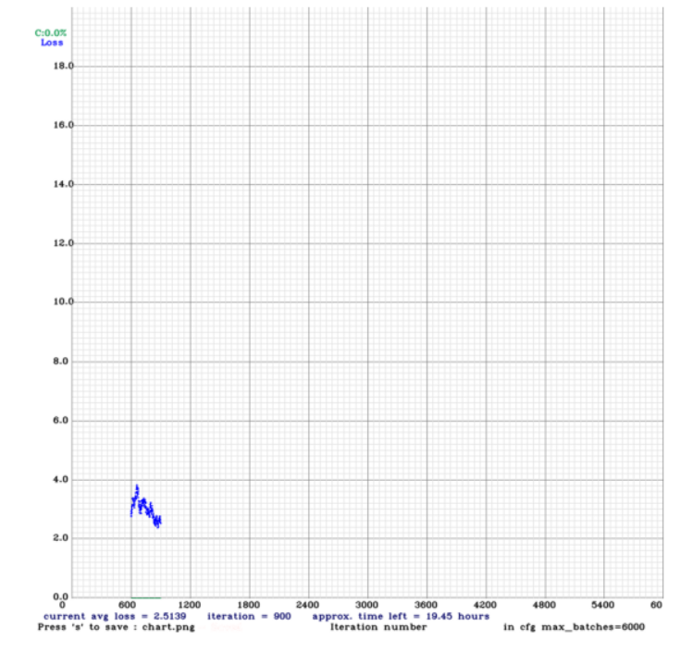

## Test our Custom Dataset

we have to change batch no=1 and subdivisions =1 in our custom config file

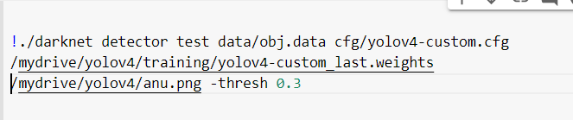

## 

## 

## 

## Results

Test the detector on the image

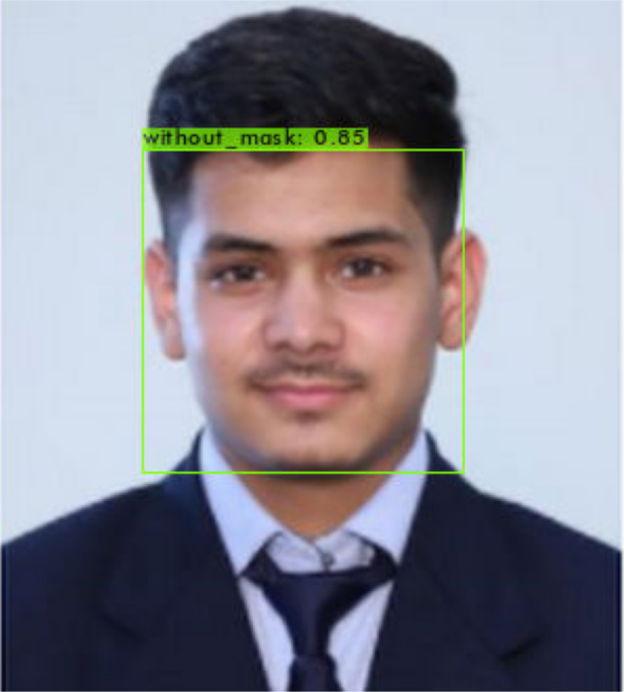

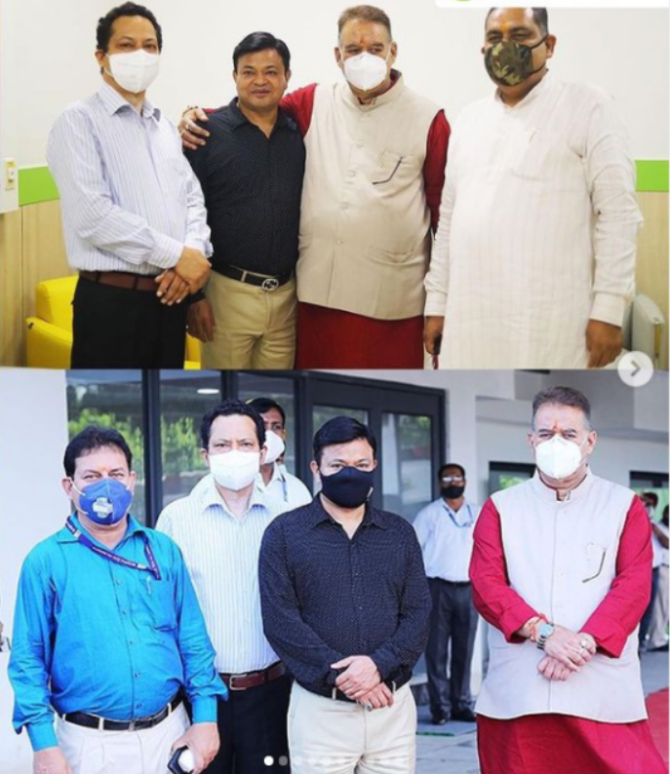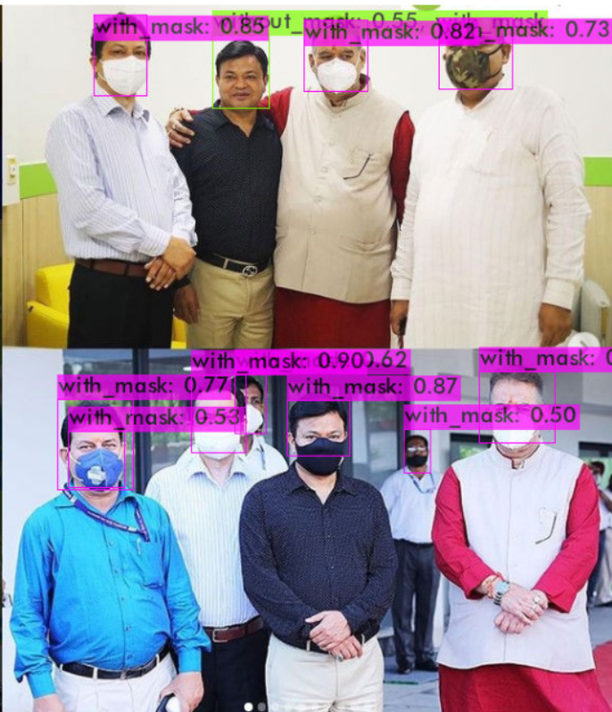

We can also test the detector on a video or on a live webcam